Simple Sitemap

Christine Hodges

Rasmussen College

Author Note

This paper is being submitted on April 29th, 2018 for Professor Darice Corey’s CIS3801 Fundamentals of Mobile Web Application Development Course.

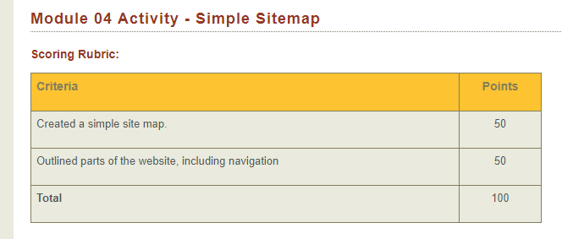

Created a simple site map:

<https://drive.google.com/file/d/1ntje83ZpuzCmaHB0VatYdaala6P4yV4e/view?usp=sharing>

Outlined parts of the website, including navigation:

